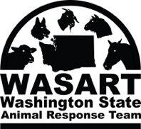
Animal ID # Procedure

- The Animal ID number starts with a minimum two-letter designator corresponding to the shelter name (i.e. the Okanogan Animal Shelter is abbreviated as “OK“).
- Next is the year followed by # of deployment for that year (OK18-1, 2018, 1st deployment to Okanogan that year)
- One master number is assigned to each owner regardless of how many animals he/she brings to the shelter. (i.e. 001, first owner, 002, 2nd owner).
- Multiple animals with the same owner are designated by letters A, B, C, etc. following the owner number (i.e. 001A, 001B, 001C).
- Offspring and young animals with their mother or born on site are assigned the mother’s Animal ID number plus an additional number (i.e. 001A-1, 001A-2). If they are to be housed apart from the mother, this will be noted on the mother’s and the offspring’s forms.
- Strays are given individual numbers unless they are known to have come from one household.
- For a herd, add the quantity of animals in the herd in parenthesis after owner ID or letter, if multiple herds from same owner

OK18-1 002A (23)

Oknogan Deployment Animal # # in Herd
Number that year
Year

Owner #

____________________________________________________________

